**Exercise 1: Control Structures**

**Scenario 1:**

BEGIN

EXECUTE IMMEDIATE 'DROP TABLE Customers';

EXCEPTION

WHEN OTHERS THEN NULL;

END;

/

BEGIN

EXECUTE IMMEDIATE 'DROP TABLE Loans';

EXCEPTION

WHEN OTHERS THEN NULL;

END;

/

CREATE TABLE Customers (

CustomerID NUMBER PRIMARY KEY,

Name VARCHAR2(100),

DOB DATE,

Balance NUMBER,

LastModified DATE

);

CREATE TABLE Loans (

LoanID NUMBER PRIMARY KEY,

CustomerID NUMBER,

LoanAmount NUMBER,

InterestRate NUMBER,

StartDate DATE,

EndDate DATE

);

INSERT INTO Customers VALUES (1, 'John Doe', TO_DATE('1950-01-01', 'YYYY-MM-DD'), 12000, SYSDATE);

INSERT INTO Customers VALUES (2, 'Jane Smith', TO_DATE('1990-01-01', 'YYYY-MM-DD'), 8000, SYSDATE);

INSERT INTO Loans VALUES (1, 1, 5000, 5, SYSDATE, ADD_MONTHS(SYSDATE, 60));

INSERT INTO Loans VALUES (2, 2, 3000, 6, SYSDATE, ADD_MONTHS(SYSDATE, 36));

COMMIT;

SET SERVEROUTPUT ON;

BEGIN

FOR cust IN (SELECT CustomerID, DOB FROM Customers) LOOP

IF TRUNC(MONTHS_BETWEEN(SYSDATE, cust.DOB)/12) > 60 THEN

UPDATE Loans

SET InterestRate = InterestRate - 1

WHERE CustomerID = cust.CustomerID;

DBMS_OUTPUT.PUT_LINE('Applied 1% discount to Customer ID: ' || cust.CustomerID);

END IF;

END LOOP;

COMMIT;

END;

/

**Output:**

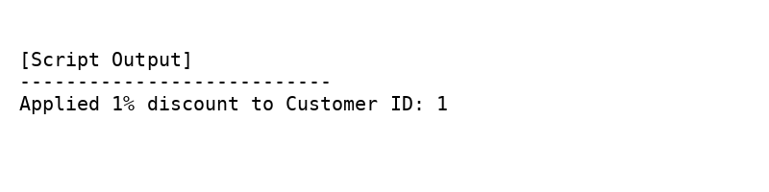

**Scenario 2:**

BEGIN

EXECUTE IMMEDIATE 'DROP TABLE Customers';

EXCEPTION

WHEN OTHERS THEN NULL;

END;

/

CREATE TABLE Customers (

CustomerID NUMBER PRIMARY KEY,

Name VARCHAR2(100),

DOB DATE,

Balance NUMBER,

LastModified DATE,

IsVIP VARCHAR2(5) DEFAULT 'FALSE'

);

INSERT INTO Customers VALUES (1, 'John Doe', TO_DATE('1950-05-15', 'YYYY-MM-DD'), 12000, SYSDATE, 'FALSE');

INSERT INTO Customers VALUES (2, 'Jane Smith', TO_DATE('1990-07-20', 'YYYY-MM-DD'), 8000, SYSDATE, 'FALSE');

INSERT INTO Customers VALUES (3, 'Robert Brown', TO_DATE('1980-02-10', 'YYYY-MM-DD'), 15000, SYSDATE, 'FALSE');

COMMIT;

BEGIN

DBMS_OUTPUT.ENABLE;

END;

/

BEGIN

FOR cust IN (SELECT CustomerID, Balance FROM Customers) LOOP

IF cust.Balance > 10000 THEN

UPDATE Customers

SET IsVIP = 'TRUE'

WHERE CustomerID = cust.CustomerID;

DBMS_OUTPUT.PUT_LINE('Customer ID: ' || cust.CustomerID || ' promoted to VIP.');

END IF;

END LOOP;

COMMIT;

END;

/

**Output:**

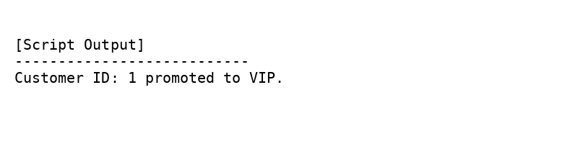

**Scenario 3:**

BEGIN

EXECUTE IMMEDIATE 'DROP TABLE Loans';

EXCEPTION

WHEN OTHERS THEN NULL;

END;

/

BEGIN

EXECUTE IMMEDIATE 'DROP TABLE Customers';

EXCEPTION

WHEN OTHERS THEN NULL;

END;

/

CREATE TABLE Customers (

CustomerID NUMBER PRIMARY KEY,

Name VARCHAR2(100),

DOB DATE,

Balance NUMBER,

LastModified DATE

);

CREATE TABLE Loans (

LoanID NUMBER PRIMARY KEY,

CustomerID NUMBER,

LoanAmount NUMBER,

InterestRate NUMBER,

StartDate DATE,

EndDate DATE,

FOREIGN KEY (CustomerID) REFERENCES Customers(CustomerID)

);

INSERT INTO Customers VALUES (1, 'John Doe', TO_DATE('1950-05-15', 'YYYY-MM-DD'), 12000, SYSDATE);

INSERT INTO Customers VALUES (2, 'Jane Smith', TO_DATE('1990-07-20', 'YYYY-MM-DD'), 8000, SYSDATE);

INSERT INTO Loans VALUES (1, 1, 5000, 5, SYSDATE, SYSDATE + 20); -- due soon

INSERT INTO Loans VALUES (2, 2, 3000, 6, SYSDATE, SYSDATE + 40); -- not due soon

COMMIT;

BEGIN

DBMS_OUTPUT.ENABLE;

END;

/

BEGIN

FOR loan IN (

SELECT LoanID, CustomerID, EndDate

FROM Loans

WHERE EndDate <= SYSDATE + 30

) LOOP

DBMS_OUTPUT.PUT_LINE(

'Reminder: Loan ID ' || loan.LoanID ||

' for Customer ID ' || loan.CustomerID ||

' is due within 30 days.'

);

END LOOP;

END;

/

